**VELAMMAL ENGINEERING COLLEGE**

# (An Autonomous Institution)

**CHENNAI–600066**



**POSTER PRESENTATION**

**For   
1st YEAR B.E / B.Tech Students**

Organized By

DEPARTMENT OF

PHYSICS

SUBMITTED TO

 INSTITUTION'S INNOVATION COUNCIL

# VELAMMAL ENGINEERING COLLEGE

**(An Autonomous Institution)**

**Department of Physics**

1. Title of the Event : Poster Presentation for 1st year B.E / B.Tech Students
2. Resource Person **:**

3. Date : 06-12- 2024 (10.30 AM – 12.30 PM)

1. Session Type : Offline
2. Program Type : offline Presentation
3. Annexure- I : List of Participants
4. Annexure- II : Broucher, Registration Form
5. Annexure- III : Photographs
6. Annexure- IV : Participants Feedback





|  |  |
| --- | --- |
| **Dr. J. Arumugam**  Event Coordinator  Department of Physics | **Dr. S. Shahil Kirupavathy**  Professor & Head  Department of Physics |

**ANNEXURE-I**

Velammal Engineering College

Department of Physics

List of Participants: All 1st Years

|  |  |  |  |  |  |
| --- | --- | --- | --- | --- | --- |
| Team | Name of the Student - 1 | Name of the Student - 2 | Name of the Student -3 | Section | Title of the poster |
| 1 | Divyaa Sree K J | Swathy S | Kasi Bharathi K | AI&DS-B | Artificial Intelligence in Early Cancer Detection |
| 2 | Divyaa Sree K J | Swathy S |  | AI&DS-B | Renewable Energy Forecasting |
| 3 | Swathy S | Divyaa Sree Kj |  | AI&DS-B | Renewable Energy Forecasting |
| 4 | Subburaj S | Vishnu varththan K | Gomagan R | MECH | Renewable energy |
| 5 | Roshini | Indhumari | Mithra | MECH | Renewable energy |
| 6 | B.Abarna |  |  | EIE | Solar energy |
| 7 | Ebinezer Joshua V |  |  | EIE | Renewable energy |
| 8 | Harshini S | Srinidhi Pm | Yazhini | CSE-A | "Energize The Future" |
| 9 | Soorya S |  |  | CSE-B | Renewable energy |
| 10 | Syed Ashraf A | Soorya s |  | CSE-B | Renewable energy |
| 11 | Soorya S | Syed Ashraff |  | CSE-B | Renewable energy |
| 12 | Soorya S | Syed Ashraff | Harish | CSE-B | Clean energy,  Clear Future |
| 13 | M. Poornashri |  |  | CSE-B | Save energy resources |
| 14 | Lakshmi Narasiman .A | Raj Kumar A |  | CSE-D | Astrophysics |
| 15 | Preethi S | Subasri R | Tejaswini PG | CSE-D | Renewable energy |
| 16 | Priyaharshini Sr | Dhanvandhini L | Kaviya Lakshmi R | CSE-D | Solar energy system |
| 17 | Madhumitha M M | Rajamani S | Sadhana R S | CSE-D | Renewable energy |
| 18 | Naveena M |  |  | CSE-D | Renewable Energy - Ocean Energy |
| 19 | Sadhana R S | Rajamani S | Madhumitha M M | CSE-D | Renewable energy |
| 20 | Pavithra E | Malavika C | Harini TG | CSE-D | Renewable energy |
| 21 | Ayesha Alfiya.Y | Sanjuktha | Nanma Elizabeth Gracious | ECE-A | Renewable energy |
| 22 | Ayesha alfiya | Sanjukta V | Nanma elizabeth gracious | ECE-A | Renewable energy |
| 23 | Nanma Elizabeth Gracious | Sanjukta V | Ayesha Alfiya | ECE-A | Renewable Energy |
| 24 | Joseph Anisto S | Muthu Saran L | Jabez Immanuel | ECE-A | Tidal energy |
| 25 | KarthiKeyan k | Karthick M | Velu | ECE-A | Renewable energy |
| 26 | Swetha U | Yazhmozhi Arasi A G |  | ECE-A | Renewable Energy |
| 27 | Pavithra lakshmi s.b | Glenys.R | Hyndhavi.c | ECE-B | Renewable energy |
| 28 | Sriragul S | Santhosh M | Harish shankara raja G | ECE-B | Renewable energy |
| 29 | Neha.S | Nandhini.V | Priyadharshini | ECE-C | Bio energy |
| 30 | Nandhini V | Neha S | Priyadharshini S | ECE-C | Bio Energy |
| 31 | J. Joshva |  |  | ECE-C | Renewal energy |
| 32 | Amruta J | Aishwarya R | Janani I | IT-B | Renewable Energy |
| 33 | S.harshitha | Anisha begum.M | Devadarshini | IT-B | Renewable energy |
| 34 | Preethika R | Pradheeksha S | Rakshaya Shri K | IT-B | Ocean Renewable energy |
| 35 | Saravana kumar U | Desigan R | Sree Varshan P | IT-B | Renewable energy |
| 36 | Pavithra J |  |  | AUTO | Renewable energy |

# ANNEXURE –II

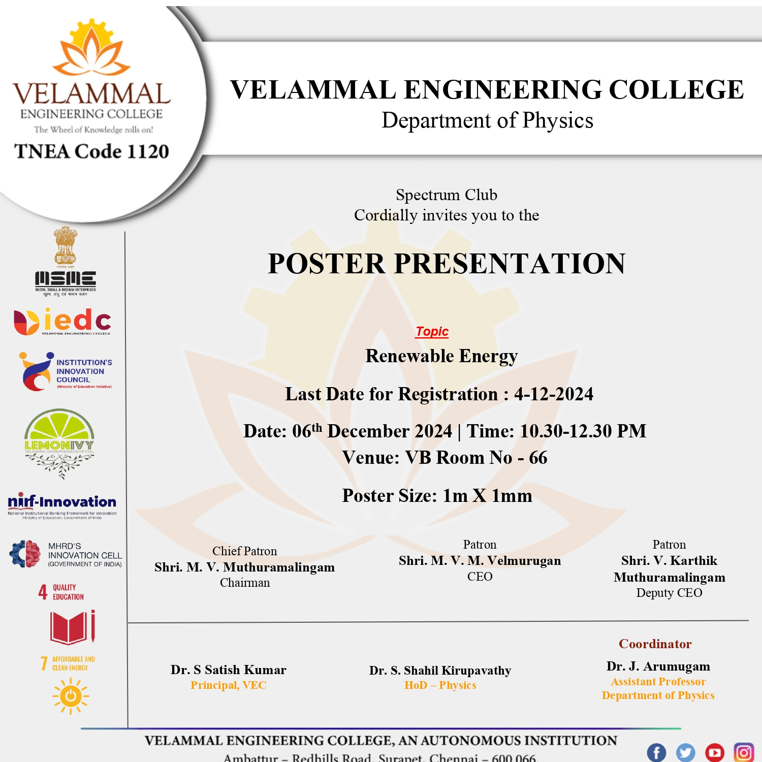

**Figure 1: Poster Presentation for 1st year VEC students**

**ANNEXURE –III**

**Photographs**

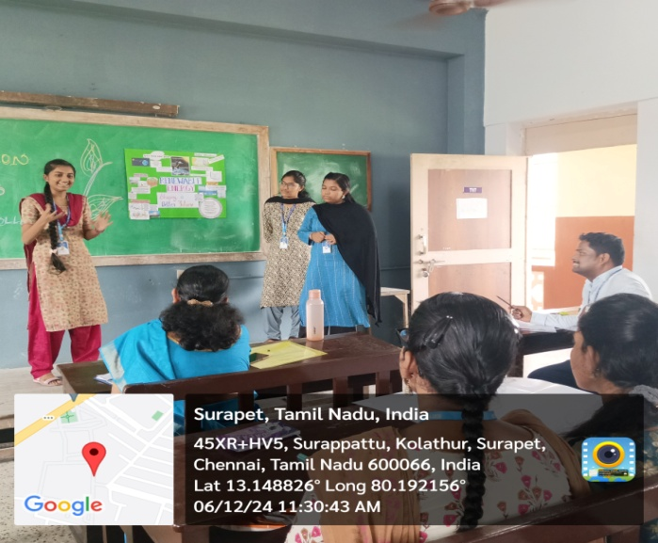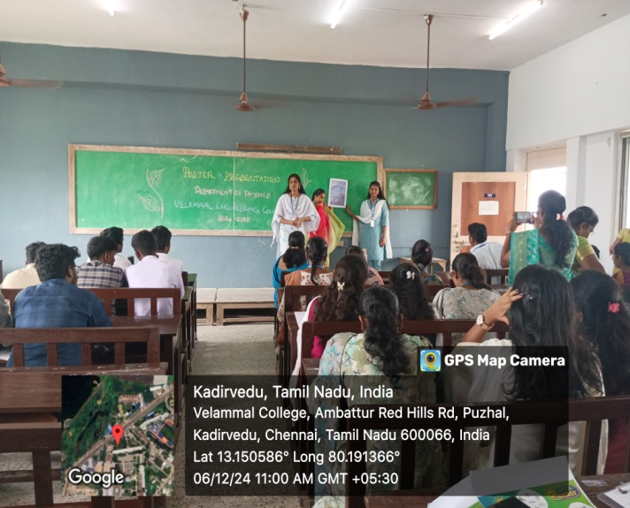

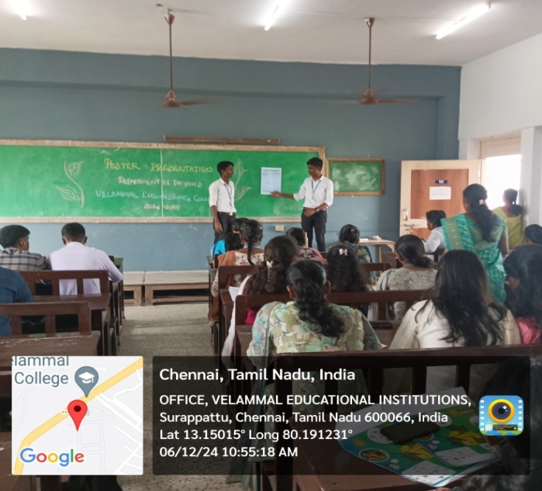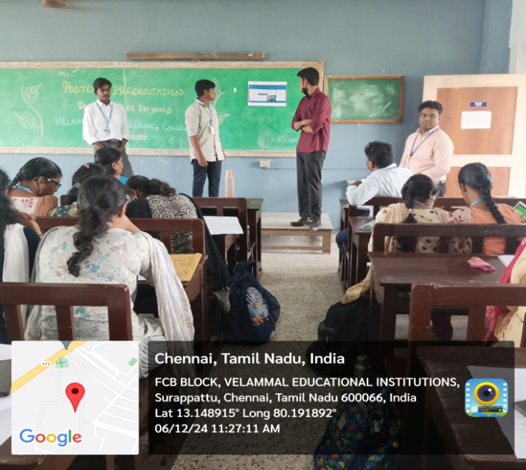

**Figure 2: photograph of the event**

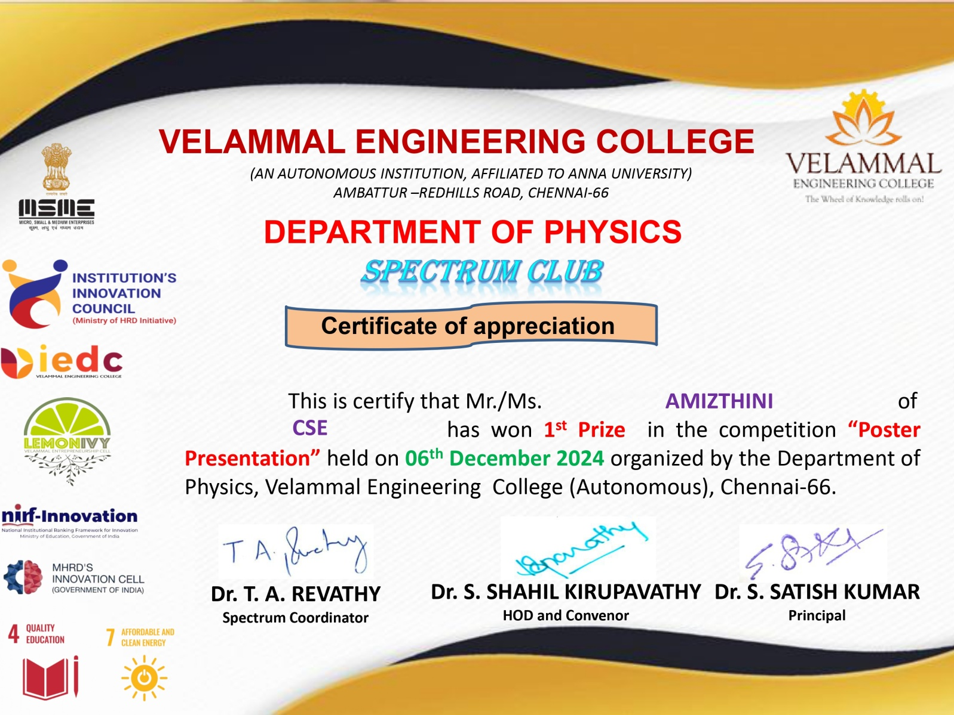

**Figure 3: Certificate of the event**

**ANNEXURE –IV**

**Table 1: Participants Feedback**

| **Sl.No** | **NAME** | **How was the Quiz?** |
| --- | --- | --- |
| 1 | B.Abarna | Good |
| 2 | Preethika R | Useful |
| 3 | Roshini | Excellent |
| 4 | Swathy S | Knowledgeable |
| 5 | KarthiKeyan k | Good |
| 6 | Pavithra E | Useful |
| 7 | Kaviya Lakshmi R | Excellent |
| 8 | Preethi S | Good |
| 9 | Lakshmi Narasiman .A | Informative |
| 10 | Sadhana R S | Very Good |